FODS LAB

Faculty: Dr.M.Kalaiyarasi Name:Ganji Madhan Kumar
CODE: DSA0405 Reg No:192472328
Course: Fundamentals of Data Science

EXP 1:
AIM:
To calculate the average score of each subject using NumPy and identify the subject with the highest average score.
PROGRAM:
import numpy as np

student_scores = np.array([
[85, 90, 78, 88],
[75, 80, 85, 70],
[90, 95, 88, 92],
[80, 85, 90, 82]
])

average = np.mean(student_scores, axis=0)
subjects = ["Math", "Science", "English", "History"]

print("Average Scores:", average)
print("Highest Average Subject:", subjects[np.argmax(average)])

Output:
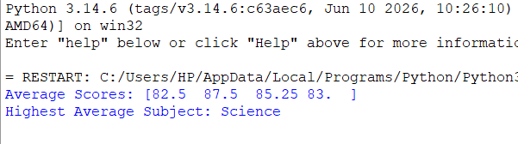

Result:
Thus, the average score of each subject was calculated, and Science was identified as the subject with the highest average score.

Exp:2
AIM:
To calculate the average price of products sold during the past month using NumPy.
PROGRAM:
import numpy as np

sales_data = np.array([
[100, 200, 300],
[150, 250, 350],
[120, 220, 320]
])

average_price = np.mean(sales_data)

print("Average Price:", average_price)
Output:

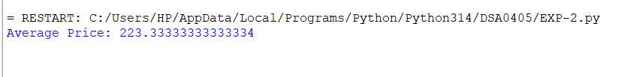

Result:
Thus, the average price of all products was calculated as 223.33.

Exp-3
AIM:
To calculate the average sale price of houses having more than four bedrooms using NumPy arrays.
PROGRAM:
import numpy as np

house_data = np.array([
[3, 1200, 200000],
[5, 1800, 350000],
[6, 2200, 450000],
[4, 1500, 280000],
[5, 2000, 400000]
])

filtered_houses = house_data[house_data[:, 0] > 4]
average_price = np.mean(filtered_houses[:, 2])

print("Average Sale Price:", average_price)

Output:
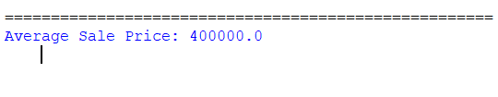
Result:
Thus, the average sale price of houses with more than four bedrooms was calculated as 400000.

Exp-4
AIM:
To calculate the total sales for the year and the percentage increase in sales from the first quarter to the fourth quarter using NumPy.
PROGRAM:
import numpy as np

sales_data = np.array([10000, 12000, 15000, 18000])

total_sales = np.sum(sales_data)
percentage_increase = ((sales_data[3] - sales_data[0]) / sales_data[0]) * 100

print("Total Annual Sales:", total_sales)
print("Percentage Increase:", percentage_increase, "%")

Output:
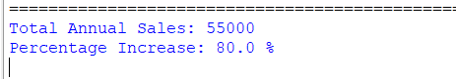

Result:
Thus, the total annual sales were calculated as 55000, and the percentage increase from the first quarter to the fourth quarter was 80%.

Exp-5
AIM:
To calculate the average fuel efficiency of car models and determine the percentage improvement between two car models using NumPy.
PROGRAM:
import numpy as np

fuel_efficiency = np.array([25, 30, 35, 40])

average = np.mean(fuel_efficiency)
improvement = ((fuel_efficiency[3] - fuel_efficiency[0]) / fuel_efficiency[0]) * 100

print("Average Fuel Efficiency:", average, "MPG")
print("Percentage Improvement:", improvement, "%")

Output:
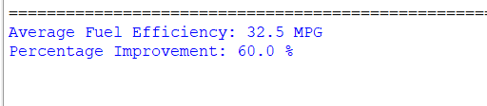

Result:
Thus, the average fuel efficiency was calculated as 32.5 MPG, and the improvement between the first and fourth car models was 60%.

Exp-6
AIM:
To calculate the total cost of a customer's purchase, including discounts and taxes, using arithmetic operations.
PROGRAM:
prices = [100, 200, 300]
quantities = [2, 1, 3]

discount_rate = 10
tax_rate = 5
subtotal = sum(p * q for p, q in zip(prices, quantities))
discount = subtotal * discount_rate / 100
amount_after_discount = subtotal - discount
tax = amount_after_discount * tax_rate / 100
total_cost = amount_after_discount + tax

print("Subtotal:", subtotal)
print("Discount:", discount)
print("Tax:", tax)
print("Total Cost:", total_cost)

Output:
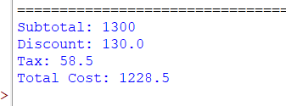
Result:
Thus, the total purchase cost after applying a 10% discount and 5% tax was calculated as 1228.50.

